**Provide Insights to the Marketing Team in Food & Beverage Industry**

**Primary Insights (Sample Sections / Questions)**

Note: These insights can be derived from the survey responses

1. Demographic Insights (examples)

a. Who prefers energy drinks more? (male/female/non-binary?) - **Male**

b. Which age group prefers energy drinks more? - **19-30**

c. Which type of marketing reaches the most Youth (15-30)? - **Online Ads**

2. Consumer Preferences:

a. What are the preferred ingredients of energy drinks among respondents? - **Caffeine**

b. What packaging preferences do respondents have for energy drinks? - **Compact and portable cans**

3. Competition Analysis:

a. Who are the current market leaders? - **Cola-Coka**

b. What are the primary reasons consumers prefer those brands over ours? - **Increased energy and focus**

4. Marketing Channels and Brand Awareness:

a. Which marketing channel can be used to reach more customers? - **Online ads**

b. How effective are different marketing strategies and channels in reaching our customers?

| Online ads | 411 |
| --- | --- |
| TV commercials | 261 |
| Outdoor billboards | 119 |
| Other | 116 |
| Print media | 73 |

5. Brand Penetration:

a. What do people think about our brand? (overall rating)

| Neutral 589 | 589 |
| --- | --- |
| Positive | 219 |
| Negative | 172 |

b. Which cities do we need to focus more on?

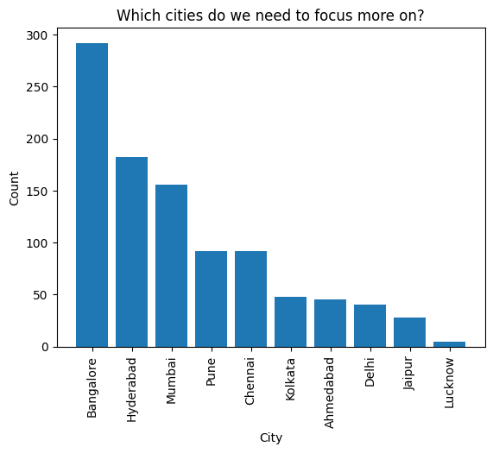

6. Purchase Behavior:

a. Where do respondents prefer to purchase energy drinks?

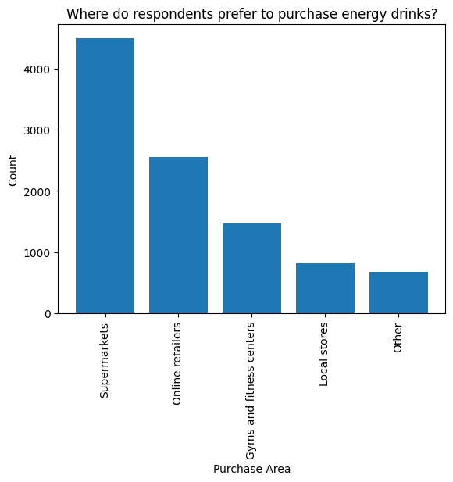

b. What are the typical consumption situations for energy drinks among respondents?

Sports/exercise 4494

Studying/working late 3231

Social outings/parties 1487

Other 491

Driving/commuting 297

c. What factors influence respondents' purchase decisions, such as price range and limited edition packaging?

Price Range:

50-99 4288

100-150 3142

Above 150 1561

Below 50 1009

Limited Edition Packaging:

No 4023

Yes 3946

Not Sure 2031

7. Product Development:

a. Which area of business should we focus more on our product development? (Branding/**taste**/availability)

Reduced sugar content - 2995

More natural ingredients - 2498

Wider range of flavors - 2037

Healthier alternatives - 1472

Other - 998

**Secondary Insights (Sample Sections / Questions)**

Note: You need to do additional market research Recommendations for CodeX:

Give 5 recommendations for CodeX (below are some samples)

● What immediate improvements can we bring to the product?

→ Flavor Enhancement

→ Packaging Innovation

→ Health and Wellness Focus

● What should be the ideal price of our product?

→ 50-99

● What kind of marketing campaigns, offers, and discounts can we run?

→ Online ads

→ TV commercials

● Who can be a brand ambassador, and why?

→ The brand ambassador can be Neha Kapoor, who is so popular and can be fit as a brand ambassador for our product, since she has a huge social media fan base in various platforms like instagram, facebook, X, etc. Hence, she can be a good fit to be the ambassador for our product.

● Who should be our target audience, and why?

→ People of age 19-30 should be our target audience, since these people are consuming more beverages compared to other age groups.